<https://learnit.itu.dk/mod/page/view.php?id=186412>

**Task:**

1. Choose the most appropriate agile software process model and write a short text giving the rationale for your choice.

We have chosen scrum as the software process model for our project. We chose this model because it provides a clear framework for the delegation of roles and work in our group, and allows every member to have visibility of all tasks currently in progress, thus ensuring that everyone is aligned and on the same page. The short sprint-style of iterative and incremental work is a perfect fit for the toll-gate style of project deliverables that we are expected to provide, and allows us to get concurrent feedback on our product and project throughout the process.

Size. Well documented (lots of ressources).

*Ressources:* Page 87 in the book,

2. Briefly, explain the pros. and cons. of the candidate process models to satisfy the key qualities for your case. Please consult with course materials (book, additional readings) for this task. You are also welcome

|  |  |  |
| --- | --- | --- |
|  | Pros | Cons |
| Scrum |  |  |
| Extreme programming | Test-first development process. Key to define and meet requirements for ease of use and trustworthiness. | Developer focused |

me to explore the web for more ideas (I have provided a folder named "Helpful Material" with official sources).

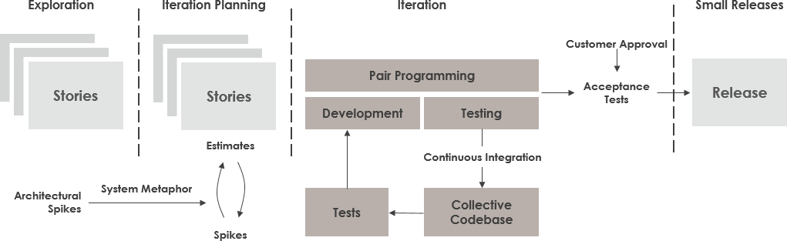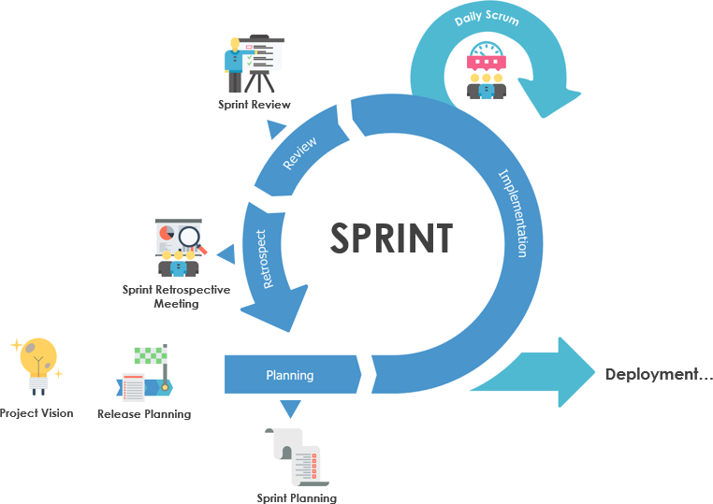

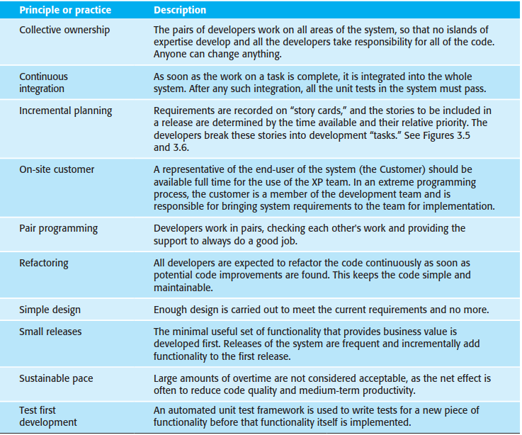

**Outcome:**

Decision made about which development process model to use in the project + rationale for the choice.

**Deadline:**

In time for the next exercise session/supervision meeting.

**Feedback:**

The choice of development model will inform all other project related activities you will implement during the course. The main feedback will therefore be your own experience later.